Internal Voltage Model for a Generator in PST V3

pstV3p1

Dan Trudnowski

June 2020

Draft 2

# Introduction

This report describes a new method to model a voltage-behind-impedance generator model in PST. I term this an “Internal Voltage Model” (IVM) for a generator. Such a model is used to model a grid-forming inverter-based generator.

The IVM is a voltage behind impedance model. The interface model is in Figure 1 below where *VT* is the terminal voltage. Internal voltage magnitude *E* and angle *δ* are calculated via a user-defined model thru time constants *Tv* and *Td*, respectively. The user-defined model is written in function *ivmmod_dyn.m* which is called every integration time step and allows for dynamic states to be defined. Any number of model structures can be modeled. Time constants *Tv* and *Td* are defined in the *mac_con* settings.

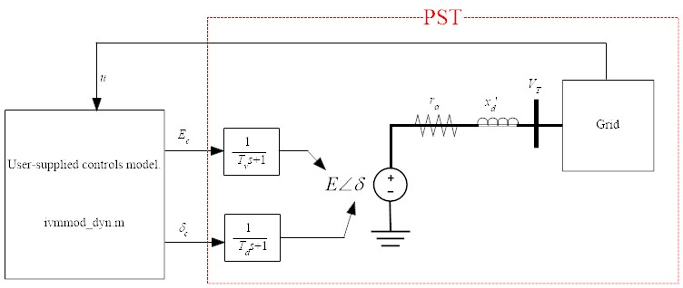

Figure 1: IVM Interface model.

# Declaring IVM Buses

The IVM bus is handled as a generator in PST and must be declared as a voltage-controlled bus type 2 in the “bus” matrix. The parameters are set in the *mac_con* matrix. It is recognized by PST by setting the inertia constant (H) to zero. The format with an example:

% col 1 generator number

% col 2 bus number

% col 3 generator MVA base

% col 4 Not used

% col 5 r_a

% col 6 Not used

% col 7 x’_d

% col 8 Not used

% col 9 Td

% col 10 Tv

% col 11 Not used

% col 12 Not used

% col 13 Not used

% col 14 Not used

% col 15 Not used

% col 16 0 (this is H for a syn generator)

% col 17 Not used

% col 18 Not used

% col 19 bus number

% An example:

mac_con = […

% 1 2 3 4 5 6 7 8 9 10 11 12 13 14 15 16 17 18 19

% num bus base NA r_a NA x'_d NA Td Tv NA NA NA NA NA 0 NA NA bus

3 2 100 0 0 0 0.1 0 0.05 0.05 0 0 0 0 0 0 0 0 2];

# Defining a model in *ivmmod_dyn.m*

The function *ivmmod_dyn.m* is used to define the IVM model to set the variables *δc* and *Ec* in Figure 1. The function is called every integration step and allows for arbitrary dynamic models. Key variables are defined in the comments in the function along with the below examples.

# Example 1

Consider the system in Figure 2 with an IVM generator placed into bus 2. The data file is *d2m_ivmmod1.m*. The IVM input voltage (*Ec* in Figure 1) is set to the initial-condition voltage of *E* plus a step of 0.1 pu at *t* = 1 sec. The IVM input voltage angle (*δc* in Figure 1) is set to the initial-condition angle of *δ* plus a step of 0.2 radians at *t* = 4 sec. The control model is in *ivmmod_dyn_Example1.m*. The script to run the non-linear simulation and plot the results is the file *Example1.m*. The results are shown in Figure 3.

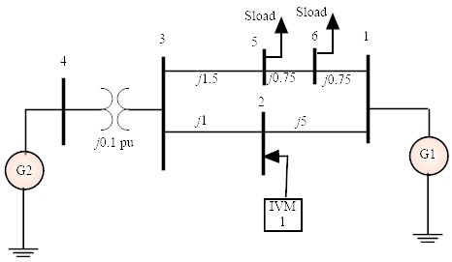

Figure 2: Example one-line.



Figure 3: Example 1 simulation result.